Experiment 2

File Viewing Commands

Aim
To execute and understand the usage of less, more and vi commands.

Theory

less Command
Displays file contents page by page.
less filename.txt

more Command
Displays file contents one screen at a time.
more filename.txt

vi Command
Text editor used to create and edit files.
vi filename.txt

Procedure
- Create a text file.
- Open the file using less.
- Open the file using more.
- Edit the file using vi.

Result
Successfully executed file viewing and editing commands.

Output For Less:

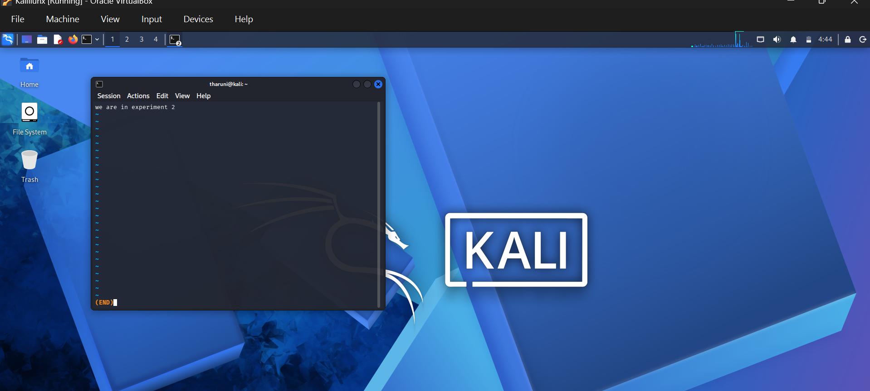

Output For Vi:

